Image | 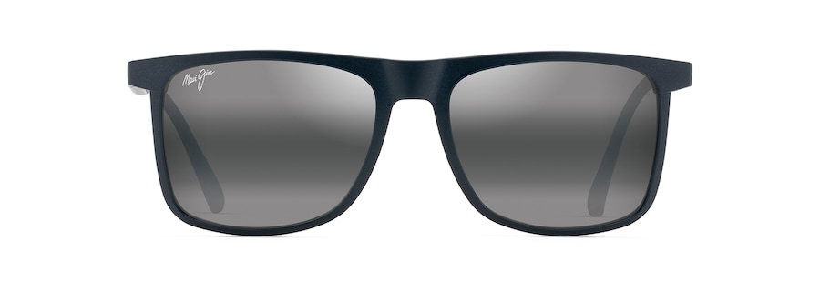
Brand | MAUI JIM
Model Name | MAKAMAE
Price | RS 2890
PRODUCT DETAILS

